**Project Proposal Description**

1. **Member**

Bùi Văn Thành - 20200585

Đỗ Tùng Lâm - 20215218

1. **Title**

Football League management system

1. **Context:**

Building a DB to manage information of league, footballers, clubs, matches in Football League

1. **Description**

The system allows Admin, Team Leader, Customer and Guest to manage related information about, the league, clubs, players, matches in Football

League:

4.1. Entities in database:

a. Player

|  |  |  |
| --- | --- | --- |
| No | Attribute name | Note |
| 1 | **player_id** | Unique ID for a player |
| 2 | Player_name | Player’s name |
| 3 | Nation | Player’s nationality |
| 4 | Position | Position of the player in line-up |
| 5 | Age | Player’s age |

b. Club

|  |  |  |
| --- | --- | --- |
| No | Attribute name | Note |
| 1 | **club_id** | Unique ID for a club |
| 2 | club_name | Club’s name |
| 3 | Nation | Name of the country |
| 4 | *Stadium_id* | ID for club that the player is playing for |

c. Matches:

|  |  |  |
| --- | --- | --- |
| No | Attribute name | Note |
| 1 | **Match_id** | Unique ID for a match |
| 2 | Home_club_id | Home team’s id |
| 3 | Away_club_*id* | Away team’s id |
| 4 | *Lyear_id* | ID for a year of the league |
| 5 | Score | Score of the match |
| 6 | Attendance | Number of Attendances in the stadium |
| 7 | Referee | The main referee’s name |

d. League year (Lyear): the relation stores information related a season (league year) of a specific league

|  |  |  |
| --- | --- | --- |
| No | Attribute name | Note |
| 1 | **lyear_id** | Unique ID for a year of league |
| 2 | Season | Season year |
| 3 | Champion | The champion’s name |
| 4 | Num_of_squad | Number of teams in the season |
| 5 | Champion_point | Number of points the champion got |
| 6 | Top_scorer | The top scorer’s name |
| 7 | Goals | The number of goals top scorer scored |
| 8 | *League_id* | ID for a league |

e. League

|  |  |  |
| --- | --- | --- |
| No | Attribute name | Note |
| 1 | **league_id** | Unique ID for a league |
| 2 | League_name | The league’s name |
| 3 | First_season | The first season was held |
| 4 | Won_most_title_club | The club’s name won the most titles |

f. Stadium

|  |  |  |
| --- | --- | --- |
| No | Attribute name | Note |
| 1 | **stadium_id** | Unique ID for a league |
| 2 | Team | The team owns the stadium |
| 3 | Name | Stadium’s name |
| 4 | Capacity | Stadium’s capacity |

g. Match statistics

|  |  |  |  |
| --- | --- | --- | --- |
| No | Attribute name | Note | Group |
| 1 | ***match_id*** | Unique ID for a match | Primary key |
| 2 | ***Player_id*** | Unique ID for a player |
| 3 | Short_passes_completed | Number of short passes completed (successful) | Passing |
| 4 | Short_passes_attempted | Number of short passes attempted |
| 5 | Long_passes_completed | Number of long passes completed (successful) |
|  | long_passes_attempted | Number of long passes attempted |
| 7 | Assists | Number of assists of a player in the match |
| 8 | Live | Number of live-ball passes | Pass types |
| 9 | Dead | Number of dead-ball passes |
| 10 | Free_kick | Number of free kicks |
| 11 | TB | completed passes sent between back defenders into open space |
| 12 | Sw | Pass > 40 yard |
| 13 | TI | Number of throw-Ins taken |
| 14 | CK | Number of corner kicks taken |
| 23 | Def_pen | Number of touches in penalty areas | Possession |
| 24 | Def_3rd | Number of touches in defensive 1/3 |
| 25 | Mid_3rd | Number of touches in middle 1/3 |
| 26 | Att_3rd | Number of touches in attacking 1/3 |
| 27 | Succ | Dribbles completed successfully |
| 28 | Att | Dribbles attempted |
| 29 | Mis | Number of times a player when attempting to gain control of a ball |
| 30 | Dis | Number of times a player loss control of a ball after being tackled by an opposing player |
| 15 | tkl_def_3rd | Tackles in defensive 1/3 | Defensive actions |
| 16 | tkl_mid_3rd | Tackles in the middle 1/3 |
| 17 | tkl_att_3rd | Tackles in attacking 1/3 |
| 18 | dribblers_tkl | Number of dribblers tackled |
| 19 | dribblers_att | Total number of dribblers |
| 20 | intceptions |  |
| 21 | pass_block | Number of passes blocked by a player |
| 22 | shot_block | Number of shots blocked by a player |
| 31 | Total_shot | The total number of shots | Shot |
| 32 | Goals | Number of goals |
| 33 | Shot_on_target | Number of shots on target |
| 34 | Penalty_made | Number of penalties made (success) |
| 35 | Penalty_attempted | Number of penalties attempted |
| 36 | Avg_distance | The average distance of all shots |

h. is_member

|  |  |  |
| --- | --- | --- |
| No | Attribute name | Note |
| 1 | ***club_id*** | Unique ID for a club |
| 2 | ***Player_id*** | Unique ID for a player |
| **3** | **Season** | ID for club that the player is playing for |
| 4 | Match_played | Number of matches played for |
| 5 | Goals | Number of goals |
| 6 | Assist | Number of assists |

Relational Diagram

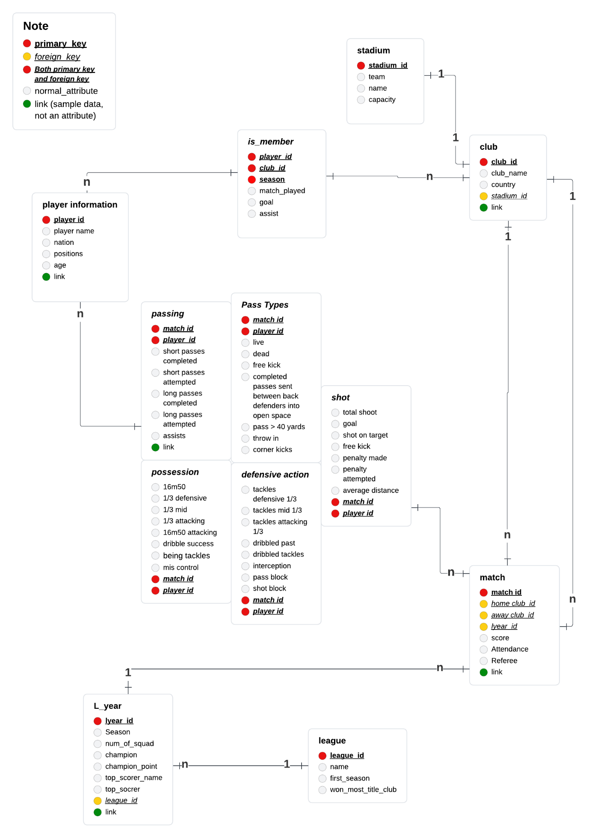

Link diagram: [https://lucid.app/lucidchart/849106cf-52f6-4004-a1f2-6d74f6b74101/edit?invitationId=inv_226b5965-1ebd-45ea-ad37-a4ea69050964&page=0_0#](https://lucid.app/lucidchart/849106cf-52f6-4004-a1f2-6d74f6b74101/edit?invitationId=inv_226b5965-1ebd-45ea-ad37-a4ea69050964&page=0_0)

4.2. Entity-Relationship Diagram

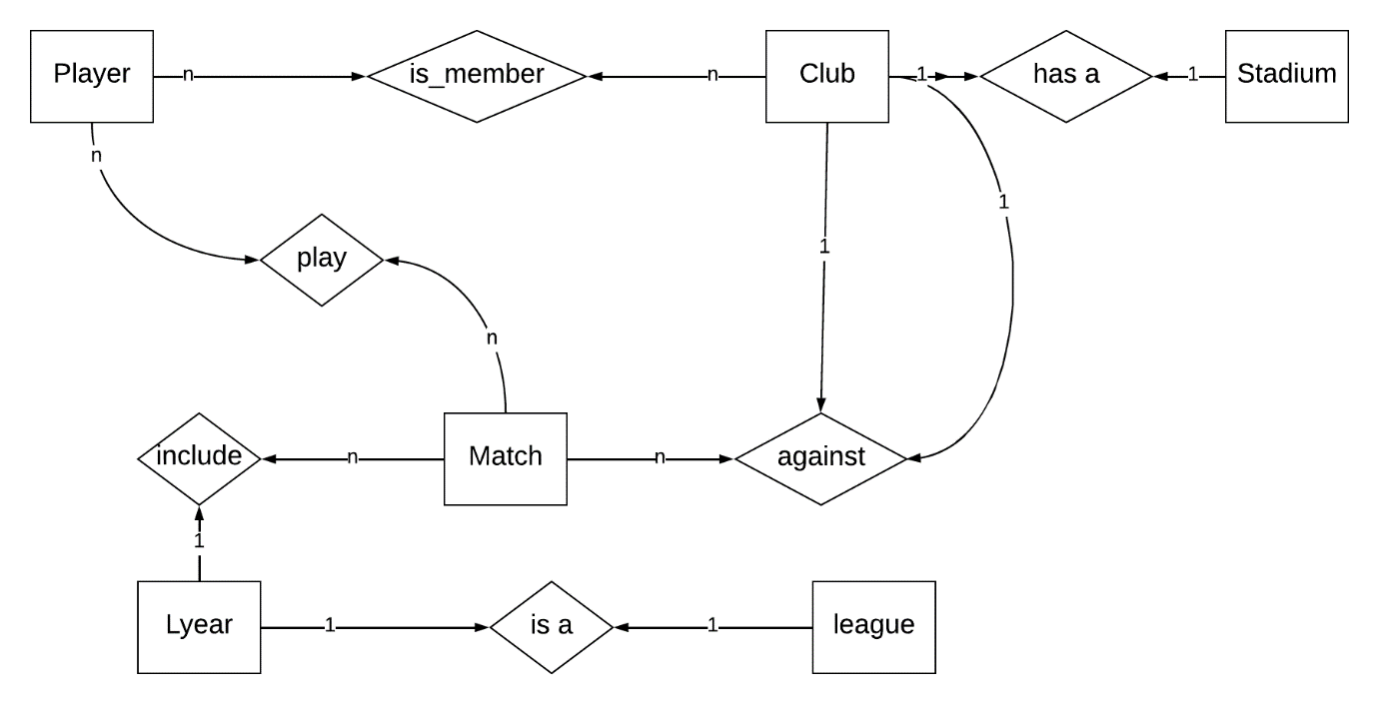

[https://lucid.app/lucidchart/849106cf-52f6-4004-a1f2-6d74f6b74101/edit?invitationId=inv_226b5965-1ebd-45ea-ad37-a4ea69050964&page=0_0#](https://lucid.app/lucidchart/849106cf-52f6-4004-a1f2-6d74f6b74101/edit?invitationId=inv_226b5965-1ebd-45ea-ad37-a4ea69050964&page=0_0)

4.3. Several basic functions

* Insertion:
* Deletion:
  + Delete by ID
  + Delete when satisfying some conditions à Delete by ID
* Modification: update data when
* Search:
  + Search based on attributes (a filter)
  + Search by ID (fastest way)
* Sorting:
  + Sort based on attributes. E.g: sorting by name first, age second, …
  + Sort by ID

4.4. Role of each user

* Admin: Insert, Update, delete and export all database
* Team Leader: all functions of guest, update, insert, delete and export the data of this team
* Customer: all functions of guest, export data, only read some restricted data
* Guest: view basic data (following tables), search and sort by categories